***The Confederation Debates***

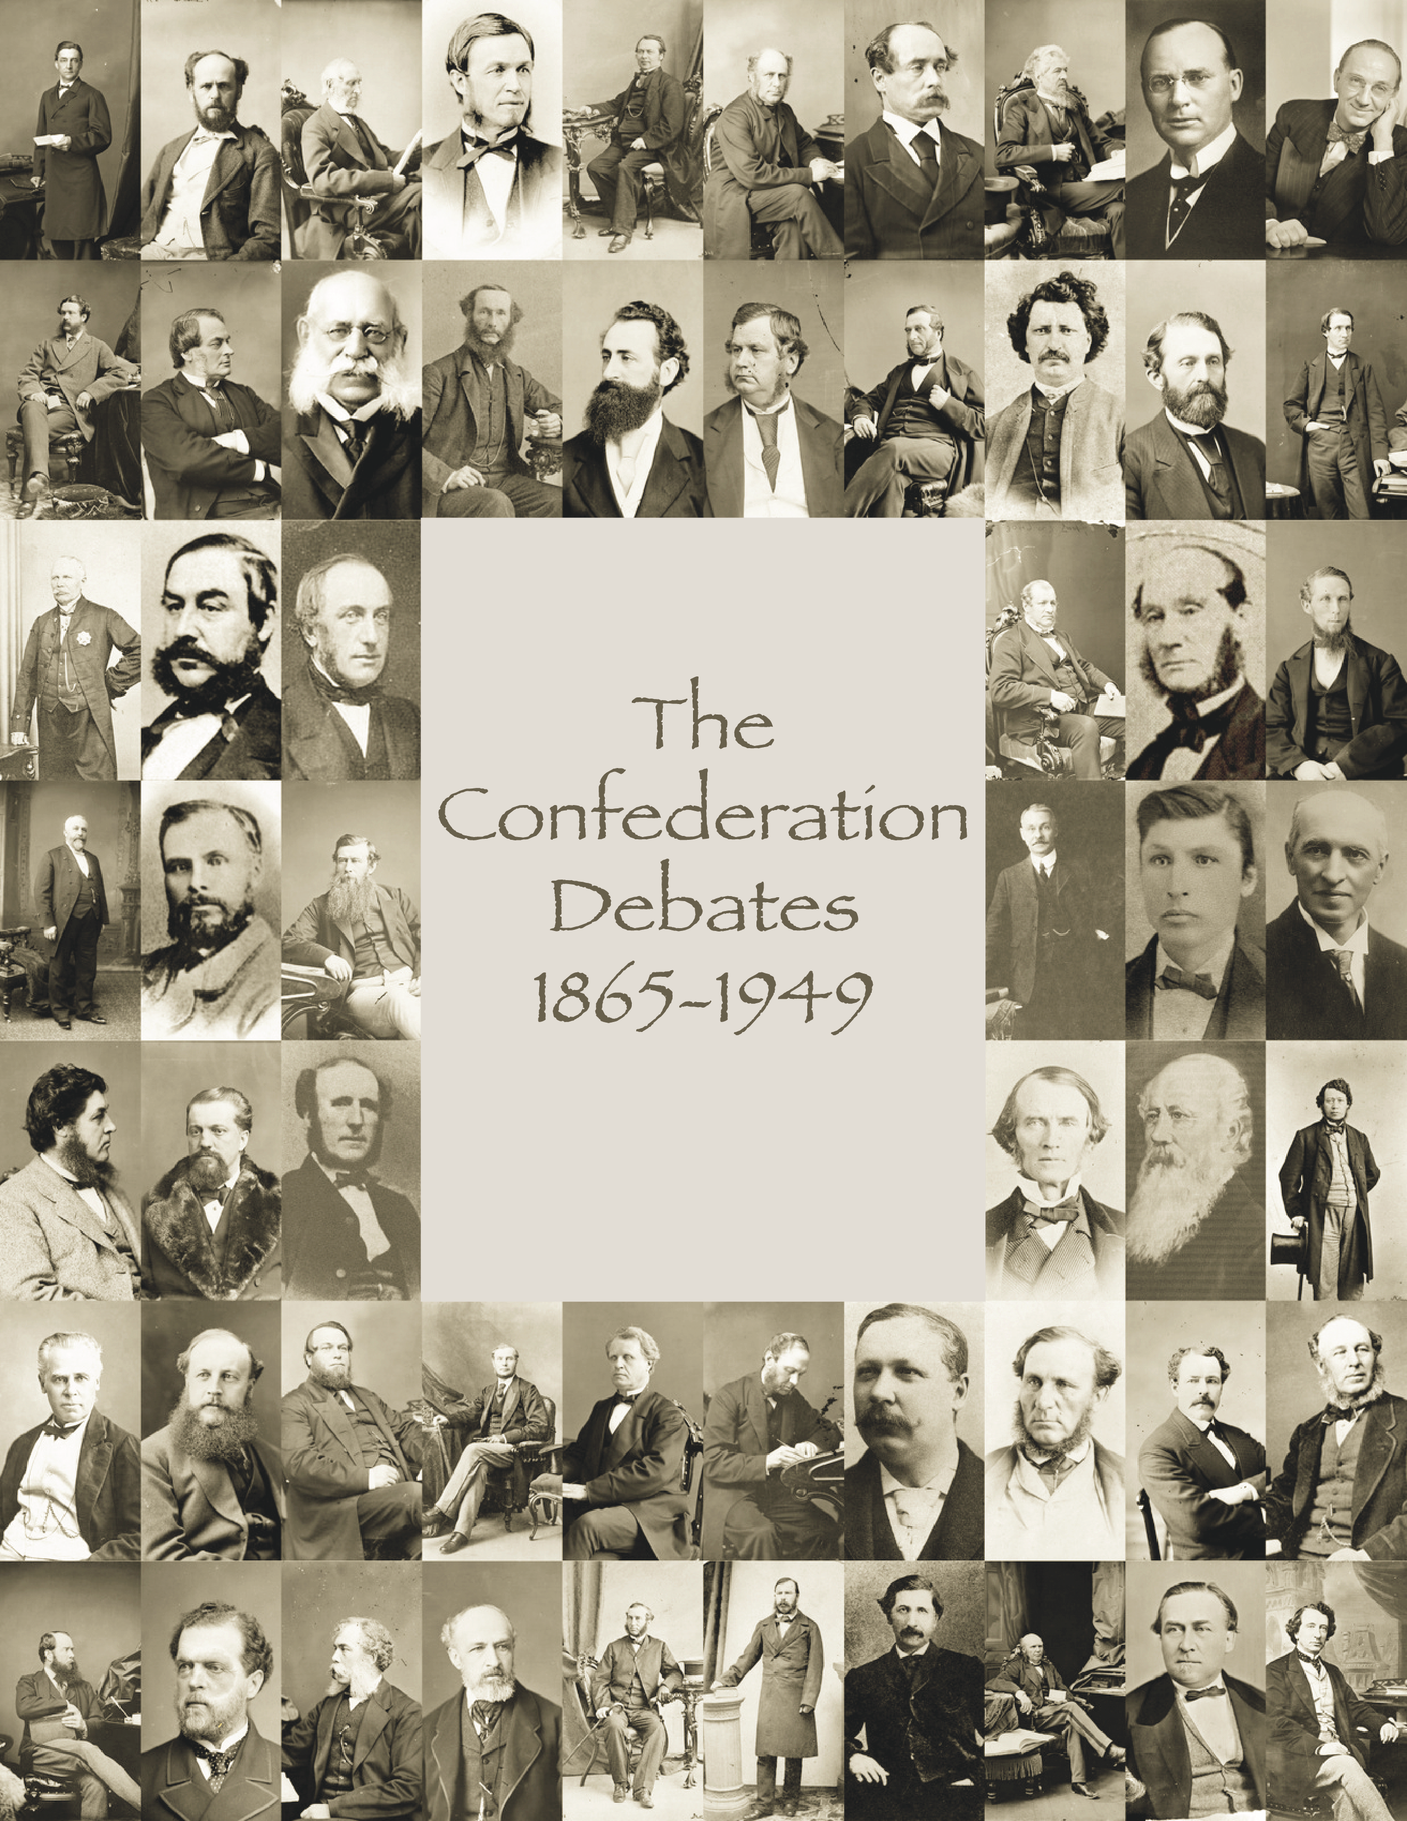 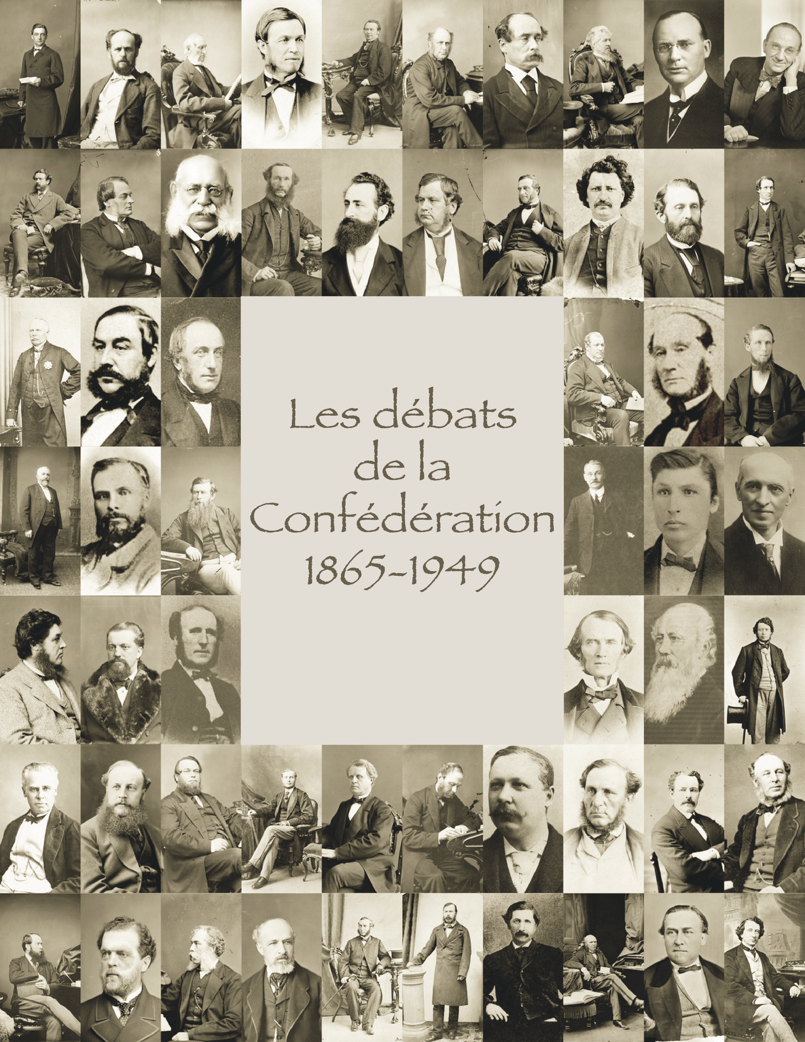

**Transcription Tutorial**

## Table of Contents

Table of Contents 1

Introduction: 2

Setup 3

A) Dropbox Setup 3

B) Google Drive Setup 3

C) Download and Install KompoZer 3

Transcribing Your Documents 5

Select a Page to Review 5

General Guidelines 5

Names From the Previous Page 6

Tables 7

Quotes 7

Creating and Deleting Lines Breaks and Paragraphs 8

Marking Column Breaks 8

Correcting Missing or Obscured Letters or Words 10

Saving Your Changes 10

Flagging Quotes 11

Flagging Text for the “Confederation Quote of the Day” 11

Flagging Text for the Education Committee 12

## Introduction:

Although we are working on a sleeker transcription platform, it will not be ready for several months. Given the urgency of getting under weigh, as well as the enthusiasm of our transcription volunteers, we have developed a transcription tool using Dropbox and Kompozer. Both this platform, and the later model will have similar functionality, so training for the former will prepare you for using the latter.

By the end of this tutorial you will:

* Learn how to use Dropbox, download your files, and store your changes,
* Learn how to use Google Drive to suggest “Confederation Quotes of the Day,”
* Install and learn to use KompoZer to edit individual HTML pages.

IMPORTANT: I have also prepared a 28-minute video that demonstrates many of the steps described in this guide. Although there is obviously considerable overlap, the video does not contain all of the important information. It is an aid, rather than a substitute for, this guide. You can download the video here: <https://youtu.be/9ii_rHeviwg>.

## Setup

Before you can begin reviewing documents, you will need to perform the following steps on the computer that you will use for your transcription work.

### A) Dropbox Setup

If you do not already have a Dropbox account, please first:

1. go to <https://db.tt/cjjrMDVp>.
2. Install the Dropbox desktop software available at <https://www.dropbox.com/install>.

Regardless of whether you needed to do steps 1 and 2, please:

1. Send the email address associated with your account to [danielheidt@trentu.ca](mailto:danielheidt@trentu.ca),
2. In the email, indicate how many pages of text you want him to include in your first batch,
3. Wait for Daniel Heidt to send you an invitation to the Dropbox folder containing your files.

### B) Google Drive Setup

If you do not already have a Google account, navigate to <https://accounts.google.com/signUp?service=mail> and create one.

Regardless of whether you needed to create an account, please send the associated email address to [danielheidt@trentu.ca](mailto:danielheidt@trentu.ca) so that Daniel Heidt can share the applicable Google Docs tracking sheets.

### C) Download and Install KompoZer

KompoZer is a free HTML editor that you will use to view and edit the OCRed files. Download the “latest development version” (0.8b3) at <http://www.kompozer.net/download.php>.

Also download the “English (British)” or French dictionary (to improve spellcheck accuracy) on the same download page. To install this dictionary:

1. in KompoZer's main menu, click Tools > Extensions (on Mac “Add-ons”)
2. in the "Extensions" window, click "Install" button
3. Use the file browser to select the *.xpi file
4. in the "Software installation" window, click "Install Now" button
5. restart KompoZer
6. Open the KompoZer’s preferences and ensure that the “Advanced” tab’s settings match the screenshot below. Ensure that “markup” is set to “XHTML 1” and “Strict.” Also check that “Special characters” is set to “Use &#..; notation for all non-ASCII characters.”

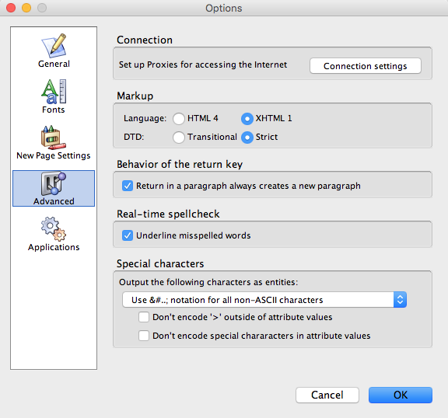

## 

## Transcribing Your Documents

### Select a Page to Review

To edit a page, simply open Finder (OS X) or Windows Explorer and select an XHTML file using KompoZer, as well as the corresponding JPG. For easy comparisons, position the two files side by side on your screen.

Be sure to input your name, the current date, and the correct page numbers into the [square brackets] in the green header before you start the file. Do not delete any of the text outside of the square brackets in the header.

### General Guidelines

Please consider the following guidelines when correcting the text:

Always reproduce the original text. 19th century texts often have unusual quirks including odd spacing between punctuation. Please preserve these sorts of details. This includes preserving the words within their lines.

Give special attention to the following common errors produced by OCR scanning:

1. Misspelled names
2. Incorrect transcription of numbers
3. Incorrect transcription of punctuation
4. the word “I” (which the software often incorrectly transcribes as a ‘1” or as “l”)
5. Highlighted words: we use a “certainty” variable produced by the OCR process to highlight words that the software was unsure of. The software often gets these words correct, but it is important to check.
6. Note the difference between “-“ and “—“. — is sometimes used to separate names from a speech, or to create a sense of pause. - is used to link works that are divided between two lines.

### Names From the Previous Page

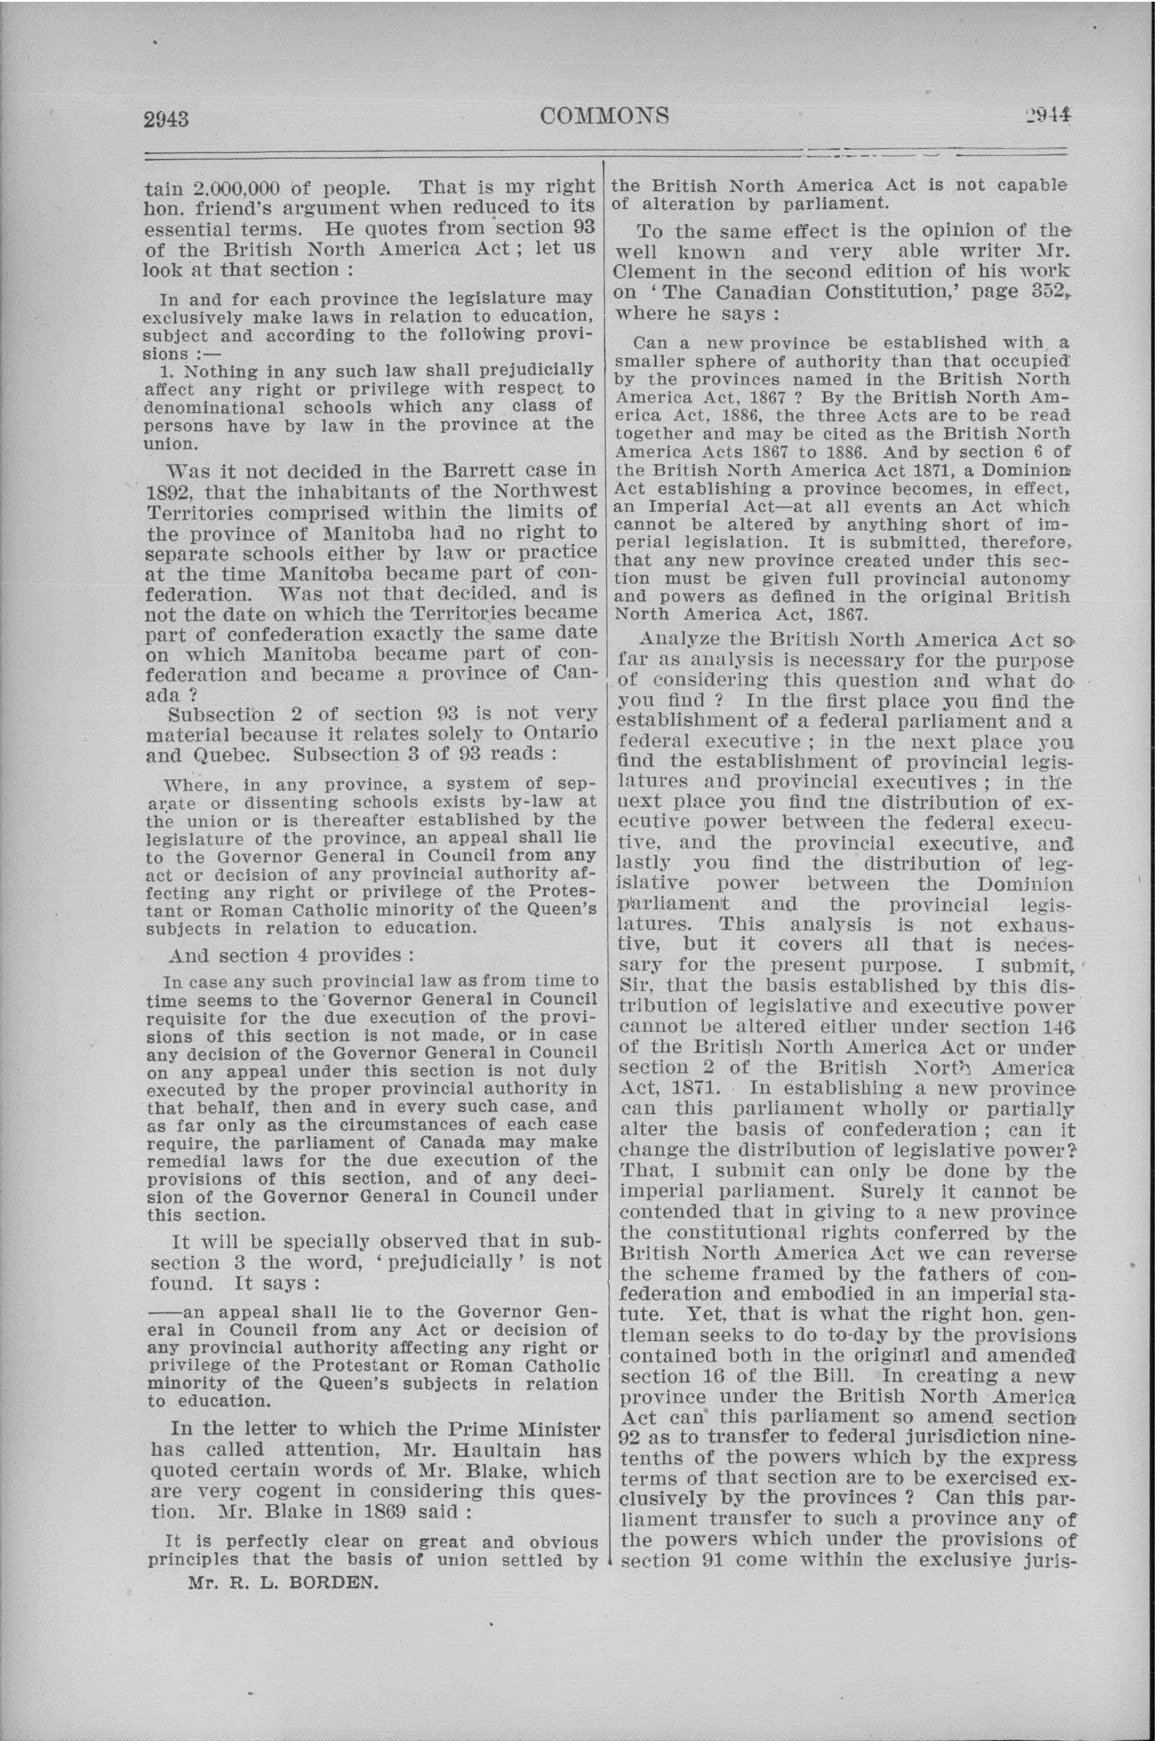

Delete the names of speakers when they appear at the bottom-left corner of a page like in this example (right).

### Macintosh HD:Users:danielhheidt:Desktop:Screen Shot 2015-12-23 at 3.31.36 PM.pngTables

Do not attempt to format tables (right). Instead, correct any spelling or number errors, write the word “table” in the header of the HTML file, and move onto the next paragraph. These tables will require more coding knowledge than most volunteers can handle and will be transcribed by a separate team.

### Quotes

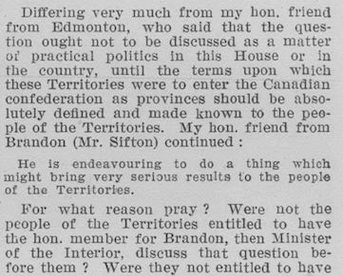

Sometimes, the speakers will quote another source. These quotes are usually typed in a smaller text that sometimes also has tighter margins. DO NOT attempt to replicate this formatting. Instead, simply make sure that the words and characters are all correct. Like data tables (see point 6 above), a different team will apply this formatting to the quotes.

### Creating and Deleting Lines Breaks and Paragraphs

Do not worry about regular paragraph indentation. As long as regular paragraphs are separated entities (as shown by a spacer on the left margin in the screenshot to the right), our team’s programmers will take care of the rest.

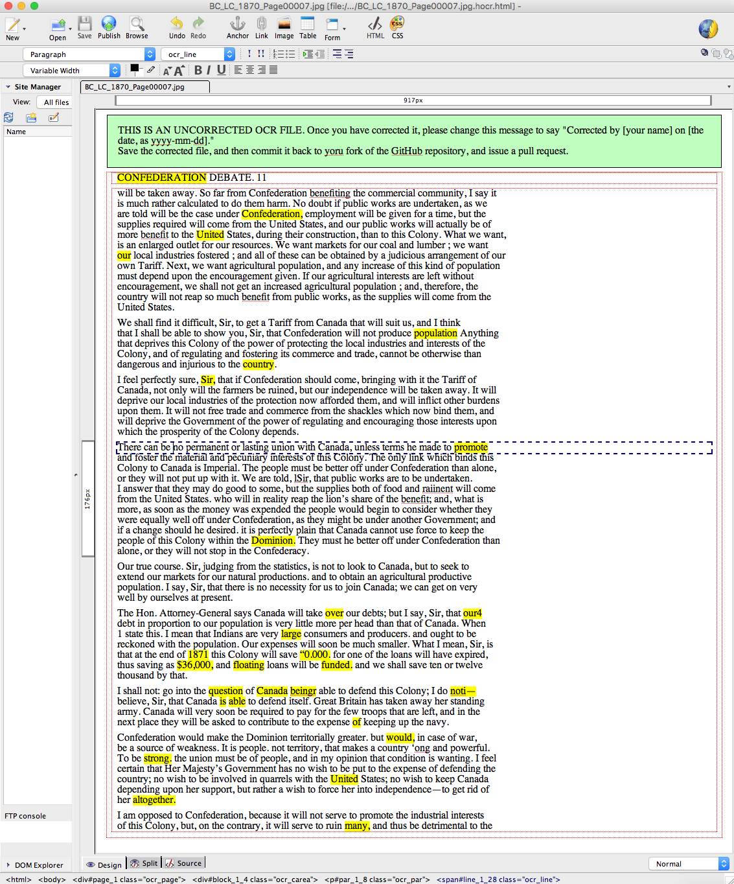

The best way to ensure that a block of text is its own paragraph is to click the “split” tab at the bottom of your Kompozer window, and ensure that the text is surrounded with <p> sample text </p> tags highlighted in red in the example below.

</br> create line breaks, and must be preserved.

If you need to add lines to a paragraph, hit the “return key.”

If you need to remove lines, put your cursor at the end of the preceding paragraph and hit the “delete” key. When you hit this key, Kompozer will replace the </p> at the end of a line with line break </br>.

If the OCR did not run well, and you are missing a lot of text, you will use this a lot to create lines and paragraphs.

### Marking Column Breaks

If you are working on a page that has 2 or more columns, we need you to add <hr/> between each column.

* 1. Note the final words of the first column
  2. At the bottom of the Kompozer window, click the “source” tab
  3. In the File Menu, select “Edit, Find and Replace,” input the last word, and use the window to find the text. The end of the paragraph will look something like this (note the </p>):

<p class="ocr_par" dir="ltr"> Mr. <span class="lowConfidenceOcr">FOSTER.</span>

Is that

sufficient without <br />

a reason ? <br />

</p>

</div>

<div class="ocr_carea" id="block_1_13" title="bbox 986 311 1752 1030">

<p class="ocr_par" dir="ltr"> Mr. FIELDLING. The minister has given <br />

* 1. After the </p> and </div> (if there is one) type “<hr />” to mark the end of the column. Your code will now look like the following:

<p class="ocr_par" dir="ltr"> Mr. <span class="lowConfidenceOcr">FOSTER.</span>

Is that

sufficient without <br />

a reason ? <br />

</p>

</div>

<hr />

<div class="ocr_carea" id="block_1_13" title="bbox 986 311 1752 1030">

<p class="ocr_par" dir="ltr"> Mr. FIELDLING. The minister has given <br />

* 1. When you back to the “Design” tab at the bottom of the KompoZer window, you will now see a black line separating the two paragraphs (see below).

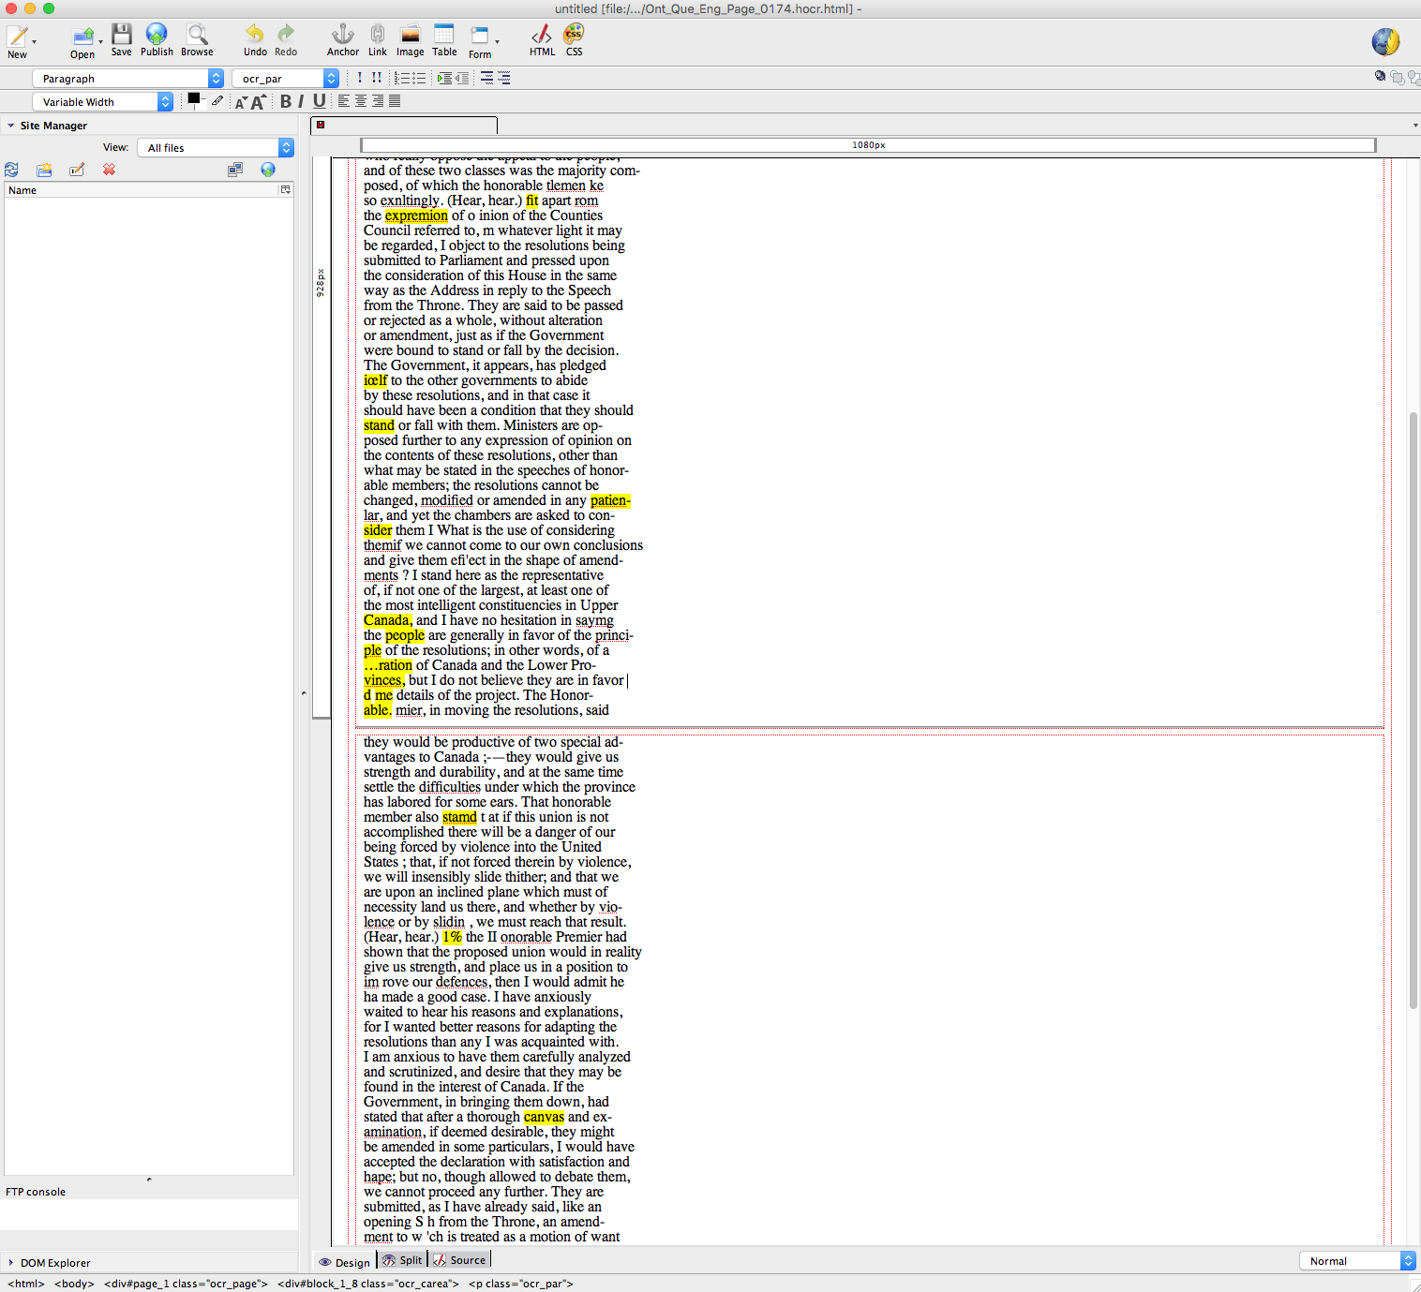

* 1. To be clear, NEVER delete any of the code when marking columns. You only need to add the <hr />.

### Correcting Missing or Obscured Letters or Words

The only other time that you will need to code is when characters are missing or obscured like in this screenshot (right). When this happens:

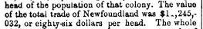

* 1. Select the “Source” tab from the bottom of the Kompozer window
  2. Find the text in the code.
  3. Insert the following code.

<span class="unclear" title=“BRIEF DESCRIPTION OF THE PROBLEM IN YOUR OWN WORDS”>?</span>

So, to correct the missing letter in the screenshot (shown above), you would place this code around the missing character, as shown below:

of the total trade of Newfoundland was $1<span class="unclear" title=“Number is missing a digit.”>?</span> ,245,-

NOTE: you must insert a single “?” to represent the missing or obscured word or character.

### Saving Your Changes

To save your changes, just click the “Save” button in KompoZer. Dropbox will automatically upload your changes to the cloud.

## Flagging Quotes

### Flagging Text for the “Confederation Quote of the Day”

When you find a part of a speech that is amusing, interesting, prophetic, completely wrong, or otherwise memorable, our Social Media Committee will want to consider posting it as a “Confederation Quote of the Day” between 1 July 2016 and 1 July 2017. To alert the committee to the quote you found:

1. Navigate to Google Drive in your web browser,
2. Open the “Confederation Quote of the Day Tracking Sheet” file,
3. Type the appropriate information into columns A-E,
   1. NOTE: if you cannot find the date, just include the page number)
4. Copy and paste the quote from Kompozer into column F.
   1. NOTE: You must paste the text into the “fx” formula bar (see image below) or the text will paste into multiple fields. To do this, click to the right of the “fx” icon, paste the text, and then hit “enter.”

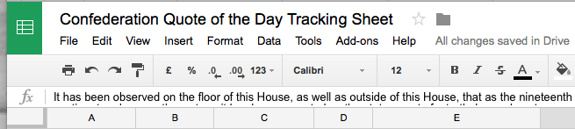

* 1. Do not edit the grey columns. They are for the Social Media Committee’s use.

### Flagging Text for the Education Committee

The Education Committee is developing lesson plans for grade 7-8 students across the country that will make heavy use of the primary documents you are transcribing. The chart below identifies the key themes for each province.

When you find a part of a speech that demonstrates the themes outlined above.

1. Navigate to Google Drive in your web browser,
2. Open the “Confederation - Useful content for Debate Guides - Tracking Sheet” file,
3. Type the appropriate information into columns A-E,
   1. NOTE: if you cannot find the date, just include the page number)
4. Copy and paste the quote from Kompozer into column F.
   1. NOTE: You must paste the text into the “fx” field (see image below) or the text will paste into multiple fields.



* 1. Do not edit the grey columns. They are for the Education Committee’s use.

The content that you cut and paste into this spreadsheet should follow the guide below. Please locate your province within the list and cut and paste any content that applies to listed themes.

|  |  |
| --- | --- |
| **Province** | **Key Themes** |
| British Columbia | * Provincial autonomy within a federation * Annexationism (pro and anti) * Construction of a transportation route to Canada (i.e. road / railway) * Lack of Aboriginal voice |
| Alberta and Saskatchewan | * Federal (as opposed to provincial) jurisdiction over Crown lands and natural resources * The right of minorities to private Catholic schools vs. public (“national”) schools * Lack of Aboriginal voice |
| Manitoba | * Lack of consultation by Canada with Red River residents * Bilingualism / biculturalism * Provincial vs. territorial status * Annexation to the United States |
| Ontario and Quebec | * Representation by population * Minority rights / representation (including French-Catholic Quebecers, Frano-Ontarians, or English-Protestant Montrealers) * Lack of Aboriginal voice |
| New Brunswick | * Intercolonial Railway * Trade * Acadians * Provincial autonomy within a federation * Maritime Union * Lack of Aboriginal voice |
| Nova Scotia | * Intercolonial Railway * Trade * Maritime Union * Provincial autonomy within a federation * Lack of Aboriginal voice |
| Prince Edward Island | * Absentee land owners * Provincial debt / railway * # of federal ridings in PEI / representation by population * Maritime Union * Lack of Aboriginal voice |
| Newfoundland | * Fear that local autonomy will be lost (sub-themes may include fear of Canadian protective tariffs, higher taxes conscription, anti-French sentiment) * Maritime Union * Provincial autonomy within a federation * Lack of Aboriginal voice |